From: University Health Information Security
To: University Health Vendor/Contractor

Subject: New/Updated/Upgraded Software/Appliance/Equipment Security Questions

Please answer the questions listed below, which will assist the information security team to complete a security assessment of the item in question. Please feel free to substitute server, database, or appliance for application as necessary to suit the situation.

Please DO NOT reference other documents, attachments, or additional reference materials. The questions below were carefully considered. Trying to glean the answers to specific questions from reference material requires a level of interpretation which may not be correct.

The following are REQUIRED for all applications, appliances, servers, hardware, etc. that will reside in the University Health (UH) network. Please indicate whether your product meets these requirements by checking Yes or No. Any items checked “No” MUST be approved by both the UH CIO and a department senior VP.

Yes | No | Requirement
 | x | 1. LAPS ONLY, no local admin accounts are allowed
x |  | 2. All hardware MUST be added to the UH domain
x |  | 3. All hardware will use UH GPO
x |  | 4. PowerShell access will be controlled via GPO
x |  | 5. SecureLink is the approved method for Remote Access
 |  | a. If SecureLink is not used, MFA is required for remote log in
x |  | 6. LDAPS for AD integration
x |  | 7. Splunk, AMP, Infocyte, CrowdStrike, Nessus, MECM, SolarWinds agents MUST be installed
x |  | 8. If SSL encryption is used, TLS 1.2 or greater is required
x |  | 9. Server Reboots MUST occur every 30 – 35 days
x |  | 10. Server OS Patching will be managed by UH  If not managed by UH,  a. OS patches MUST be deployed within 60 days of release (non-emergency)  i. NOT just FDA labelled uncontrolled risks  (proof of patch frequency will be required)  b. Emergency OS patches (like CVE-2020-1942) MUST be deployed within 72 hours  (proof of compliance will be required)

Vendor:___PeriGen Inc._________________________ Name of Product or Service:__PeriWatch Surveillance__

- Will this application be hosted on premise, in the cloud, or at the vendor’s site? On premise.

- Does the application comprise of HIPAA data or other sensitive data such as PHI, PII, and PCI?

PHI being received from EMR (HL7)

- Please provide a graphic representation (Network Wire Diagram) of the communications/network infrastructure associated with the systems communications requirements. Label all ports (such as port 80 and/or 443) and services (such as SFTP, TLS 1.1, etc.) that are used or required.

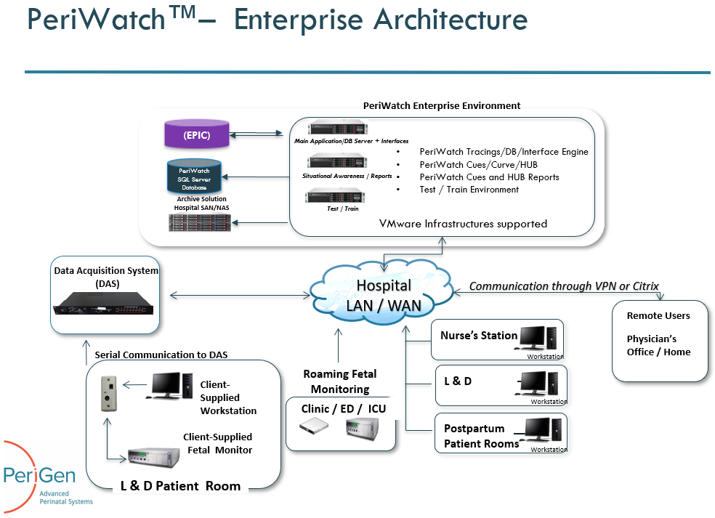

- Is this an Upgrade/New installation/Migration from an old version to a new version?

Migration of current installation to a new server.

- If this is an upgrade, please supply documentation with port requirements and justification.
What ports are currently opened?
What ports are allowed?
What ports are required? Please refer to the attached “LAB01124_r8_PeriWatch - System Requirements.pdf”

- How will the vendor/contractor connect to the application:

VPN, dedicated circuit, Internet or not required?

We presently access the server using SecureLink. No change required.

- How will a user/client connect to the application?
  - Is a mobile application available? Thick client locally and a browser-based module (if applicable) all hosted on the same server on-prem. There is no mobile app.
  - Is the mobile application controllable using a mobile device management system? No

- Does the vendor/contractor perform authenticated IP scans of your system/environment?
If so what tool is used? NA. The system in only install on-prem
If requested, can a copy of the results be provided?

- Does the vendor/contractor perform application-level scans?
If so what tool is used? Veracode but scanning only started on more recent version of the system than the one you currently use.

If requested, can a copy of the results be provided?

- What OS and version does this application require?
Is the OS upgradeable or does a new version of the application have to be purchased when an OS is EOL/EOS? Windows 2016/2019
The vendor will be required to purchase extended support if the OS is not upgradable in place.
As new version/patches are released, can it be upgraded? Yes
If so, who is responsible for testing new version/patch compatibility? Customer
If the vendor must approve patches, what is the lag time between patch release and patch approval? No
Can the application/appliance be restarted on a scheduled basis? Yes, as long as it is coordinated with OB users.
If not, please explain why.

- Does this application support SSO, AD integration, Federation or LDAPS? AD Integration/LDAPS
If so, which one and who performs the integration? Joint effort but already in operations.

- Does this application require remote access? Yes (service & support only). Already established with SecureLink.

Is remote access required for users or support?

Is it Agent Based?
If it is, is it always on or is it session-based?
Is remote access auditable and alert able?

- SecureLink is the ONLY approved remote access solution.
Note: University Health CIO approval is required for non-SecureLink remote access requests.

Already operational.

- Does this system allow the use of anti-virus software, anti-malware software? Yes, whatever system the customer already uses.
If so what specific vendors?
Who is responsible for installation, maintenance, etc.? Customer
If not, what security measures are in place to compensate for not using anti-virus/malware software?

- Does this system allow for the installation of monitoring agents such as SolarWinds, Splunk, EDR and MECM?

There should be no problem with those systems. Since this is an upgrade project, if they are already in operation on the existing PeriGen server, then there is no problem. Otherwise, a “coexistence test” could be recommended on the TEST server.

- Does this system allow for the installation of Auditing GPOs, Membership to the domain? Yes

- Does this system communicate securely both inside and outside of the corporate network? Yes (no outside communication)

- Does this application require “middleware”; such as, Java, Flash, I.E., PowerShell, or Adobe reader?
If so, is does it require a specific version of middleware?
Can it be patched or upgraded?
Who is responsible for maintenance, licensing, and upkeep?
Please note: Google chrome is not an allowed browser in the UH environment.

MS .Net and .Net Core. All supported via MS auto-updates.

- Does this application require any Microsoft Office products? No
If so, can it use an add-on or plug in instead?

If so, what version and can it be patched?
Who is responsible for patching MS Office suite?

Please provide documentation showing requirements for MS office suite or parts of the suite.

- Does this application require a Certificate? Yes.
If so, who provides the Certificate? Customer
Note: Certificate must be SHA256 or better

- Does this application require any insecure services, such as:
FTP? SFTP? FTPS? Telnet? TLS? SSL? No
If so, state which one(s) and why it cannot use a more secure version
Note: University Health does not allow TLS 1.0, 1.1; SSLv2, SSLv3 or FTP in the corporate environment.

- Does this application require dedicated hardware, such as:
OVA? University Health owned/built? Is this a hardware appliance? No
Can the OS be upgraded? Will a new appliance need to be purchased to upgrade the OS if it goes EOL/EOS?
The vendor will be required to purchase extended support if the OS is not upgradable in place.

The current version of the product supports Windows Server 2016. The latest version of the product (2022.1) supports Windows 2019. No upgrades can be done if the application specifications are not officially certified on it.

- Will this application require updates? If “this” means the PeriGen application, the answer is YES. PeriGen is in charge of those and they are coordinated with the customer.
If so, who performs them? PeriGen
What is the process? PeriGen advises the customer owner of the updates + send the release notes. Upon approval, the deployment is coordinated with the customer on the TEST env. Once deployed, the customer has to approve the changes. Once approved, the team agrees on the date to deploy in PROD.

What is the timeline? Typically, once or twice a year (varies)

- Does this application require a Vendor password? What is the process for updates? Does the application require any Admin accounts? Rights? Unique naming? Does this system support LAPS?

Yes, we require a domain service account for server access (local admin) and SQL DB admin on the PeriGen DBs. Some existing SQL accounts will be migrated to the new instance.

Printed name of person completing form ___Bruno Bendavid_______________________
Title ___SVP Product Management_______________
Email address ___Bruno.bendavid@perigen.com___________
Mobile phone number ___ 984-208-4250________________________
Land phone number ___ 984-208-4250________________________

Signed name & date ___March 15, 2023_______________________

